Advantages of Using AI in Government and Public Sector
1. Introduction
Artificial Intelligence (AI) is rapidly transforming the way governments and public sector organizations operate. AI refers to computer systems that can perform tasks that typically require human intelligence, such as learning, reasoning, problem-solving, and decision-making. Governments have started to use AI technologies to improve their operations and service delivery while solving complex problems since these systems emerged in recent years.
Public sector organizations are using AI technologies to enhance their operations in public health and disaster management and infrastructure planning and fraud detection. By using advanced algorithms with their large datasets, governments can better understand their situations and emergency response capabilities and their ability to serve citizens.
This report examines a real-world case study of AI use in public health during the COVID-19 pandemic, highlighting its benefits and challenges. The research presents an AI-based solution to enhance citizen participation in governance which demonstrates the future benefits of AI for public sector organizations.
In the public sector, governments are responsible for managing large populations, delivering essential services, and addressing complex societal challenges such as public health crises, urbanization, environmental sustainability, and economic development. Traditional administrative processes are often time-consuming, resource-intensive, and prone to human error. As a result, there is a growing need for innovative technologies like AI to enhance operational efficiency and support better decision-making.
Also, AI enables governments to shift from reactive approaches to more proactive and predictive models of governance. By analyzing historical and real-time data, AI systems can identify trends, forecast future events, and recommend appropriate actions. This not only improves policymaking but also enhances the overall quality of public services.
2. Case Study Analysis: AI in Public Health During COVID-19
2.1 Problem or Need Addressed
The governments and public health organizations had to develop fast and effective reaction systems to deal with the global crisis that emerged from the COVID-19 pandemic. The World Health Organization and the Centers for Disease Control and Prevention faced difficulties when they tried to control the virus transmission throughout the world.
AI-driven COVID-19 data tracking dashboard
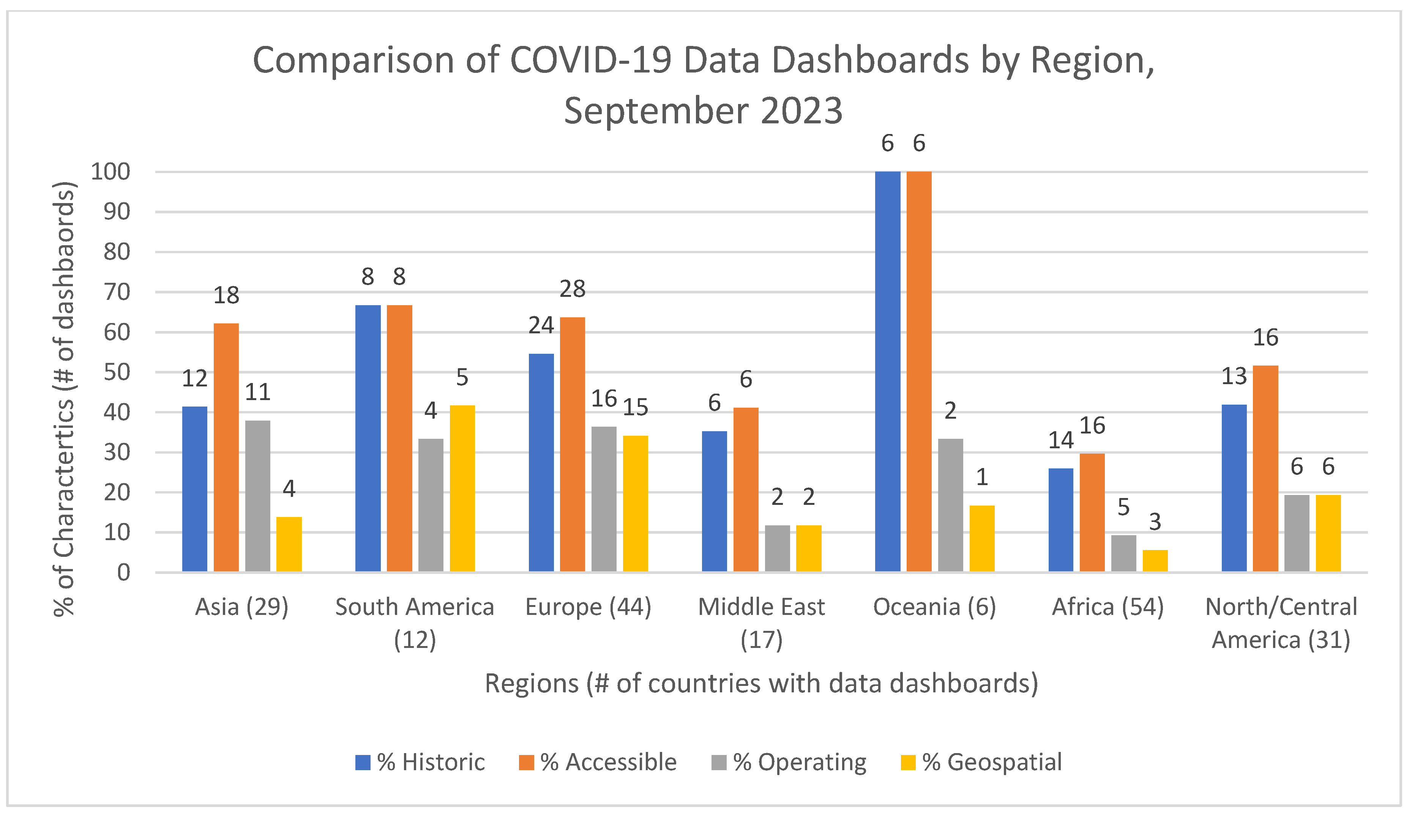
Key problems included:
The virus spread quickly from one area to another
The absence of current data made it impossible to reach decisions
Healthcare facilities faced excessive demand
The tracking and forecasting of infection patterns proved challenging
Misinformation spread through public channels while essential information remained undistributed
The pandemic required more advanced technological solutions which included AI because traditional data analysis and response systems operated too slowly to deal with the urgent circumstance.
2.2 AI Tools and Techniques Implemented
Governments and public health organizations used different AI tools and techniques during the pandemic to control the emergency situation:
1. Machine Learning Models
AI-based predictive models were used to forecast infection rates, hospitalizations, and mortality trends. The models used large datasets to detect existing patterns and forecast upcoming disease outbreaks.
2. Data Analytics Dashboards
The interactive dashboards provided continuous updates about COVID-19 cases and recoveries and fatalities. The tools enabled policymakers to take rapid decision-making based on accurate information.
3. AI Chatbots
The government used AI chatbots to deliver precise information to citizens while handling common inquiries and preventing false information from spreading.
4. Contact Tracing Systems
AI algorithms were implemented into contact tracing applications to assist in identifying individuals who might have come into contact with the virus which helped to stop its dissemination.

5. Natural Language Processing (NLP)
NLP technology analyzed social media and public communications to detect false information and analyze public sentiment toward different topics.
2.3 Outcomes and Benefits Achieved
The use of AI technologies during the COVID-19 pandemic brought about several major benefits:

Improved Decision-Making
AI-enabled predictive analytics allowed governments to anticipate outbreaks and take preventive measures, such as lockdowns and resource allocation.

Hospitals used AI-based predictions to enhance their management of essential resources including ICU beds and ventilators and medical staff.

The organization experienced enhanced response capabilities because real-time data analysis enabled staff to handle new hot spot situations at a faster rate.

AI chatbots and automated systems provided timely and accurate information which helped to reduce public panic and misinformation.

The contact tracing systems operated to detect infected people and implement their isolation process which decreased the spread of disease in the community.

2.4 Challenges and Limitations
The public health system faced multiple challenges despite experiencing the benefits that AI technology had brought to its operations.
AI in Public Health Workflow Diagram
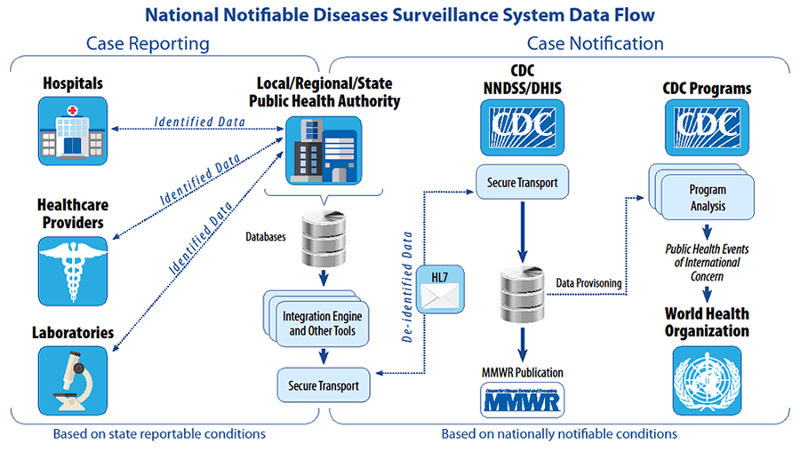
Data Privacy Concerns
The practice of contact tracing and data collection created privacy concerns regarding how personal information would be handled and secured.
Data Quality Issues
AI systems depend on accurate data yet the existence of incomplete data led to unreliable predictions because of data quality problems.
The region faced a technical barrier because some areas did not possess the necessary digital infrastructure for AI solutions to function properly.
The use of AI in surveillance and decision-making raised ethical questions about fairness and accountability.

Digital Divide
Citizens without internet access were effectively excluded from all AI-based solutions which required digital technology for operation.

3. Innovative Proposal: AI-Powered Smart Citizen Engagement System
Smart City / AI System Diagram (for Proposal Section)
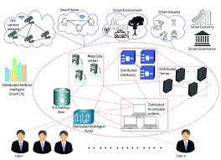
3.1 Problem Statement
The lack of effective communication between citizens and government authorities presents a significant obstacle that hinders governance. Citizens face response delays to their grievances while they deal with poor service delivery and a lack of transparency from public authorities. The situation leads to citizen dissatisfaction which results in decreased trust toward public institutions.

3.2 Proposed Solution
The report suggests that an AI-enabled Smart Citizen Engagement System should be created to enhance public sector communication systems and their ability to respond to needs while making decisions.
The system would use various AI technologies to build a central platform system that enables citizens to interact with government services through efficient channels.
3.3 Key Features of the System
AI Chatbots for Instant Communication
AI chatbots provide citizens with 24/7 access to instant answers for all their inquiries and reporting needs.
Predictive Analytics
The system can analyze patterns in complaints to predict potential issues and allow governments to take proactive measures.
Data Visualization Dashboards
Government officials can access dashboards that display trends, priorities, and performance metrics.

The implementation of this AI system would result in several benefits:
Faster Response Times: Automated systems reduce delays in addressing citizen concerns.
Public Satisfaction Increases: Citizens receive responses which are both timely and accurate.
Decision-Making Improves: Data-driven insights help policymakers prioritize issues.
Citizens can track their request status through increased transparency. Governments use proactive governance to manage problems which might become major issues.
3.5 Potential Challenges
Challenges of AI Graphic
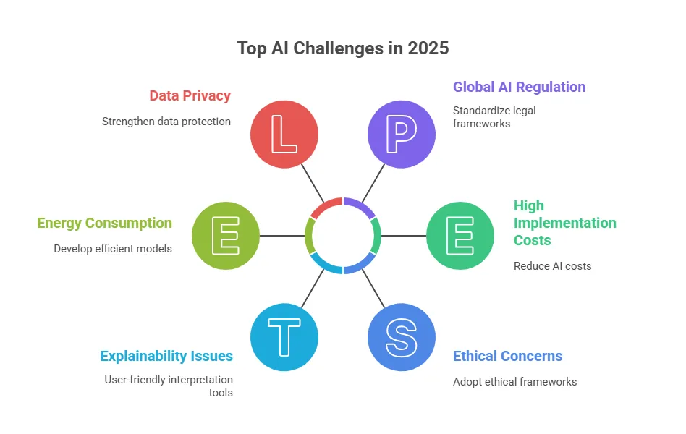
The proposed system shows promise but will encounter multiple challenges during its operation.

Data Privacy and Security Risks
High Implementation Costs
Resistance to Technological Change
Digital Literacy Barriers
Integration with Existing Systems
Governments must develop strong data protection policies and build necessary infrastructure and support digital access to handle these challenges.
4. Conclusion
Artificial Intelligence has proven to be a powerful tool in transforming government and public sector operations. The case study of AI use during the COVID-19 pandemic demonstrates how AI can enhance decision-making, improve efficiency, and support effective crisis management. The public health system used AI to solve its complicated problems through predictive analytics and automated communication systems.
The adoption of AI creates multiple challenges which include ethical considerations and data privacy issues and the limitations of existing infrastructure. Proper management of these issues will enable organizations to use AI technologies in a responsible and fair manner.
The proposed AI-powered Smart Citizen Engagement System highlights the future potential of AI in governance. Public sector organizations can achieve better performance through systems which improve communication and transparency while enabling data-driven decision-making.
AI does not provide the complete solution for all governance problems but its strategic use can improve public services which are more effective and responsive to citizen needs.
Looking ahead, the future of AI in the public sector depends on a balanced approach that combines technological innovation with strong regulatory frameworks and ethical guidelines. Governments must invest in digital infrastructure, promote data literacy, and ensure equitable access to AI-driven services for all citizens. Collaboration between public institutions, private organizations, and research communities will also be essential in driving sustainable AI adoption.
In conclusion, while AI is not a standalone solution to all governance challenges, it is a powerful enabler of smarter, more efficient, and citizen-centric public services. With careful planning and responsible implementation, AI has the potential to significantly enhance the quality of governance and improve the overall well-being of society.
Additionally, it is important for governments to focus on building public trust when implementing AI technologies. Transparency in how AI systems operate, along with clear communication about data usage, can help reduce public concerns and encourage acceptance. Training public sector employees to effectively use AI tools is also essential to maximize their benefits and ensure smooth integration into existing systems. Furthermore, continuous monitoring and evaluation of AI applications will help identify areas for improvement and prevent potential risks. By adopting a responsible and well-regulated approach, governments can fully harness the potential of AI while safeguarding the interests and rights of their citizens.

References
- World Health Organization – COVID-19 Reports
- Centers for Disease Control and Prevention – Public Health Data
- OECD Reports on AI in Government
- Academic articles from Google Scholar on AI in public sector

